jsp implicit objects-

There are 9 jsp implicit objects. These objects are created by the web container that are available to all the jsp pages.

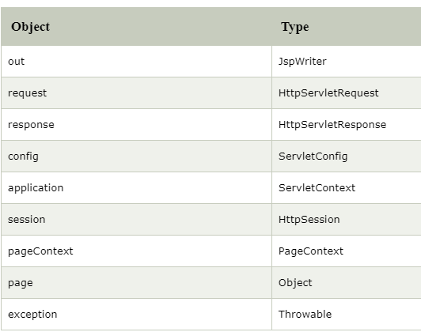

1) JSP out implicit object

1. In servlet- PrintWriter out=response.getWriter();

2.In jsp we do like this - <% out.print("Today is:"+java.util.Calendar.getInstance().getTime()); %>

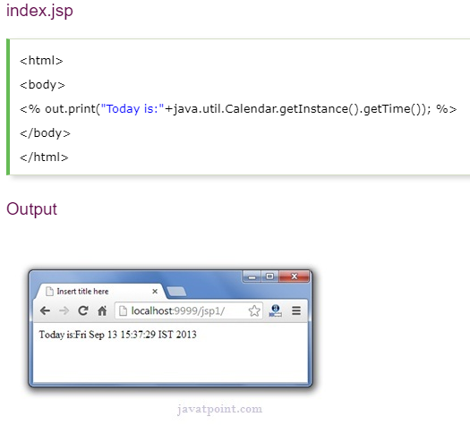

# **JSP request implicit object-**

The **JSP request** is an implicit object of type HttpServletRequest i.e. created for each jsp request by the web container

It can also be used to set, get and remove attributes from the jsp request scope.

In Servlet-“  HttpServletRequest”

In jsp direct- “request.getParameter("uname");”

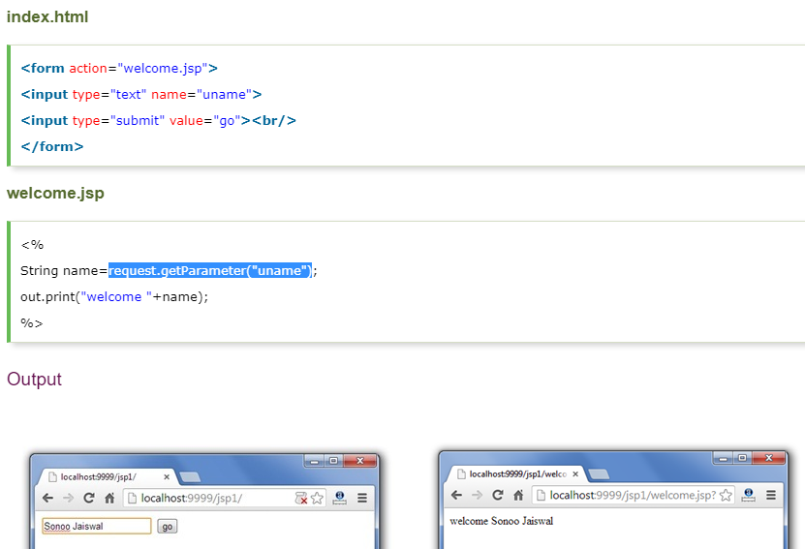

# **JSP response implicit object-**

In JSP, response is an implicit object of type HttpServletResponse. The instance of HttpServletResponse is created by the web container for each jsp request.

It can be used to add or manipulate response such as redirect response to another resource, send error etc.

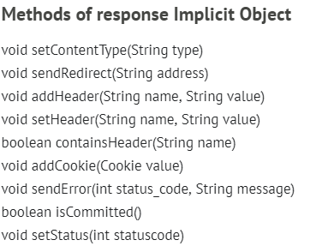

# **JSP config implicit object-**

In JSP, config is an implicit object of type *ServletConfig*. This object can be used to get initialization parameter for a particular JSP page. The config object is created by the web container for each jsp page.

Generally, it is used to get initialization parameter from the web.xml file.

### Example of config implicit object:

WEB.XML

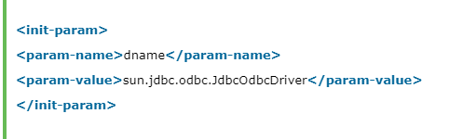

**welcome.jsp-**

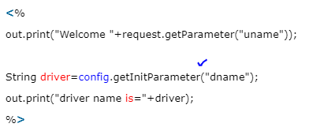

# **JSP application implicit object-**

In JSP, application is an implicit object of type *ServletContext*.

The instance of ServletContext is created only once by the web container when application or project is deployed on the server.

This object can be used to get initialization parameter from configuaration file (web.xml). It can also be used to get, set or remove attribute from the application scope.

“This initialization parameter can be used by all jsp pages.”

Example->

application.setAttribute(“MyAttribute”, “This is the value of Attribute”);

methods->

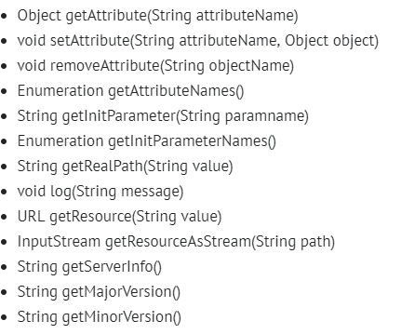

# **session implicit object-**

# In JSP, session is an implicit object of type HttpSession.The Java developer can use this object to set,get or remove attribute or to get session information.

# **pageContext implicit object-**

-

|  |
| --- |
| In JSP, pageContext is an implicit object of type PageContext class.The pageContext object can be used to set,get or remove attribute from one of the following scopes:   * page * request * session * application |
| In JSP, page scope is the default scope. |

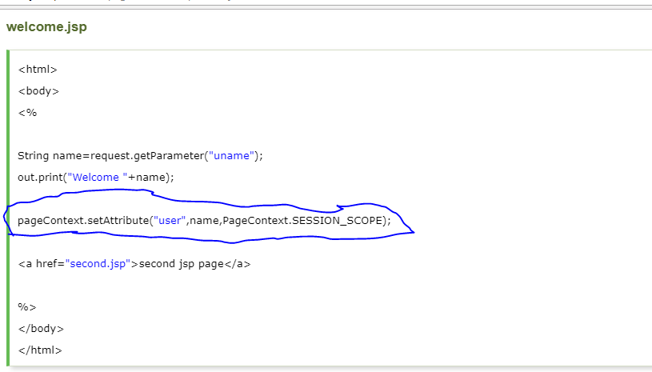\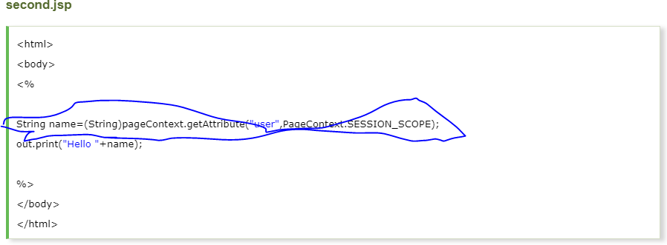

# **page implicit object:**

|  |
| --- |
| In JSP, page is an implicit object of type Object class.This object is assigned to the reference of auto generated servlet class. It is written as: |
| Object page=this; |
| For using this object it must be cast to Servlet type.For example: |
| <% (HttpServlet)page.log("message"); %> |
| Since, it is of type Object it is less used because you can use this object directly in jsp.For example: |
| <% this.log("message"); %> |